Technical Specification Document (TSD)
Sales Order Contract Data Control & Approval Workflow
Dynamic Z-Table Configuration

1. Objective
The solution controls Sales Orders created with reference to Contracts and triggers an approval workflow when specified Sales Order data is changed. Sales Document Type, Contract Type and Sales Area are dynamic and shall be maintained by authorized users in a Z configuration table. No values shall be hard-coded in ABAP.
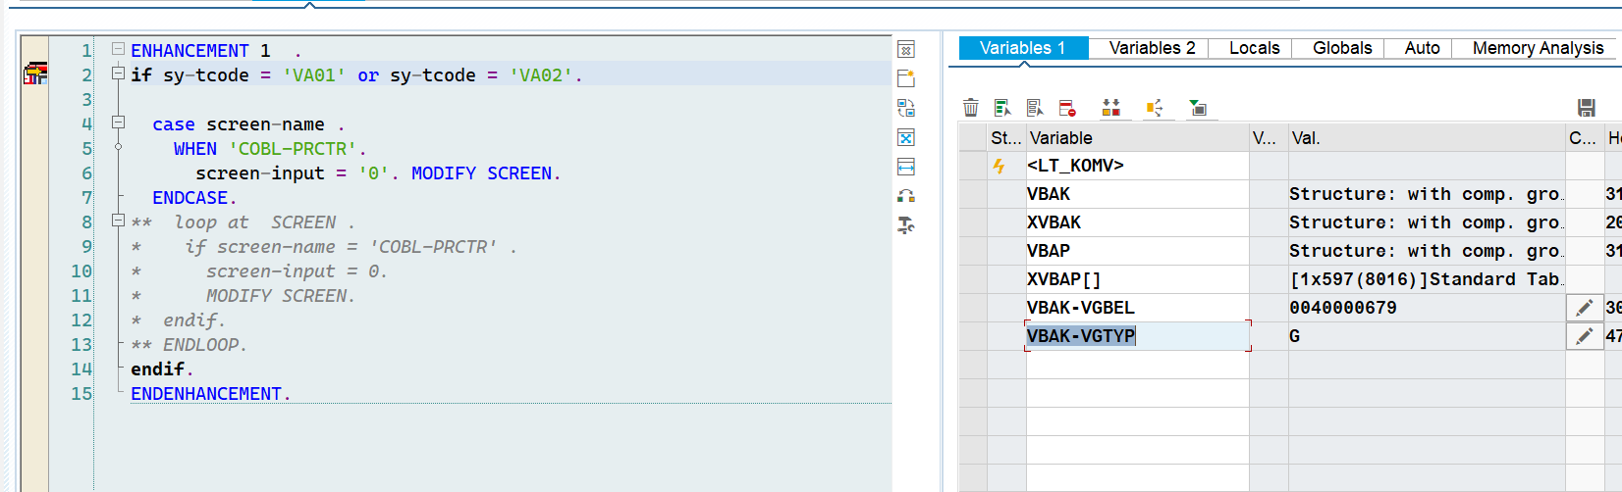

2. Dynamic Z Configuration Table
A custom Z table shall contain the combinations for which the solution is applicable.
Field | Meaning | Example | Mandatory
VKORG | Sales Organization | 2000 | Yes
VTWEG | Distribution Channel | 20/60 | Yes
SPART | Division | 00 | Yes
AUART_SO | Sales Order Type | ZOP/ZICE/ZICO | Yes
AUART_CON | Contract Type | ZCPC | Yes
ACTIVE | Active Rule | X | Yes

2.1 User Maintenance
- User enters the Sales Order Type required for the business scenario.
- User enters the Contract Type required for that Sales Order Type.
- User enters the Sales Area: Sales Organization + Distribution Channel + Division.
- User activates the rule.
- User can add another combination later without changing ABAP code.
- The same Z table is used by both VA01 and VA02.

3. Part 1 – VA01

3.1 Dynamic Applicability Check
When a Sales Order is created with reference to a Contract, the existing Copy Control remains unchanged. The system then checks the Z table.
- Read the Sales Order Type.
- Read the Sales Area.
- Search the Z table for an ACTIVE record matching Sales Order Type + Sales Area.
- If no matching record exists, do not apply the special VA01 logic.
- If a record exists, identify the referenced Contract.
- Read the Contract Type of the referenced Contract.
- Compare the Contract Type with the Contract Type maintained in the Z table.
- Only when Sales Order Type + Sales Area + Contract Type all match the active Z-table record, apply the field locking.

3.2 VA01 Field Locking
- Material
- Quantity
- Net Value / agreed copied price-related data
- Variant Configuration Characteristics
- Technical enhancement: MV45AFZZ – USEREXIT_FIELD_MODIFICATION.
- Use SCREEN-INPUT = 0 and MODIFY SCREEN for the applicable screen fields.
- The exact SCREEN-NAME values must be identified during technical development.
- Do not lock these fields for Sales Orders that do not match an active Z-table record.
- Do not change the existing Contract-to-Sales Order Copy Control.

4. Part 2 – VA02

4.1 Dynamic Z-Table Check
When the user changes a Sales Order, the system must first check the Z table before performing change detection.
- Read the Sales Order Type.
- Read Sales Organization, Distribution Channel and Division.
- Search the Z table for an ACTIVE record with the same Sales Order Type + Sales Area.
- If no matching record exists, stop the special logic. No Delivery Block and no workflow.
- If a matching record exists, identify the referenced Contract Type.
- Compare the Contract Type with the Contract Type in the same Z-table record.
- Only if the complete combination matches, continue to monitor changes.

4.2 Example
If the user changes a Sales Order with Type ZZZZ and Sales Area 1000/10/00, the system first checks whether ZZZZ + 1000/10/00 exists as an ACTIVE rule. If it exists, the system checks that the referenced Contract Type is the Contract Type maintained in that rule. Only then does it evaluate the changed fields.

4.3 Fields to Monitor
- Material – VBAP-MATNR
- Quantity – VBAP-KWMENG
- Net Value – VBAP-NETWR
- Variant Configuration Characteristics – using the configuration instance VBAP-CUOBJ and the related characteristic values using IBCD_GET_CD_CONFIGURATION

4.4 Change Detection
- Compare old and new values before save.
- Recommended enhancement: MV45AFZZ – USEREXIT_SAVE_DOCUMENT_PREPARE.
- If at least one monitored field changes, mark the Sales Order as requiring approval.
- If several monitored fields change in the same save, treat them as one change event.
- If no monitored field changes, do not trigger the approval process.

5. Delivery Block
- Set header Delivery Block using VBAK-LIFSK.
- Block code: XX (final value to be confirmed).
- Block is assigned automatically when an applicable relevant change is detected.
- User cannot manually remove or change the block while approval is pending.
- After approval, the authorized workflow process releases the block.

6. Approval Workflow
- Workflow is triggered only when the Z-table rule matches and at least one monitored field changed.
- One VA02 save creates a maximum of ONE approval workflow, even if several monitored fields changed.
- Workflow starts after the Sales Order is successfully saved.
- Delivery Block XX remains active while approval is pending.
- Approval releases the Delivery Block.
- Rejection keeps the Delivery Block according to the agreed rejection process.
- No matching Z-table rule means no workflow.

7. Technical Objects
Object / Field | Purpose | Usage
Z configuration table | Dynamic scope | Sales Order Type + Contract Type + Sales Area
MV45AFZZ / USEREXIT_FIELD_MODIFICATION | Screen control | VA01 field locking and Delivery Block protection
MV45AFZZ / USEREXIT_SAVE_DOCUMENT_PREPARE | Pre-save logic | Scope validation and change detection
VBAK-AUART | Document Type | Sales Order / Contract Type
VBAK-VKORG / VTWEG / SPART | Sales Area | Dynamic Z-table check
VBAP-VGBEL | Reference Contract | Identify referenced Contract
VBAP-MATNR | Material | Change detection
VBAP-KWMENG | Quantity | Change detection
VBAP-NETWR | Net Value | Change detection
VBAP-CUOBJ | Configuration Instance | VC change detection
VBAK-LIFSK | Delivery Block | Approval blocking

8. Important Technical Note
USEREXIT_SAVE_DOCUMENT_PREPARE is used for pre-save validation/preparation. The actual workflow trigger shall occur after successful Sales Order save using the appropriate post-save/event mechanism supported by the customer's S/4HANA Private Edition release. The exact event mechanism is to be confirmed during technical design.

9. Acceptance Criteria
- User can maintain Sales Order Type, Contract Type and Sales Area in the Z table.
- Adding a new combination does not require ABAP code modification.
- VA01 locks the agreed fields only when the complete Z-table combination matches.
- VA02 checks the Z table before change detection.
- VA02 detects Material, Quantity, Net Value and agreed VC characteristic changes.
- Relevant change sets Delivery Block XX.
- Only one workflow is triggered per save.
- No workflow is triggered when the Z-table rule does not match.
- User cannot manually release the block while approval is pending.
- Approval releases the block through the authorized process.

10. Open Items
- Final Z-table technical name.
- Final Sales Order Types, Contract Types and Sales Areas.
- Final Delivery Block code.
- Exact VA01 screen field names.
- Exact Variant Configuration characteristics in scope.
- Final workflow/event mechanism.
- Rejection and resubmission behavior.

